Media Visit: Guided Tour through Yanfeng’s Technical Center in Trenčín on 22 June 2023
01 Our Technical Center in Trenčín, Slovakia

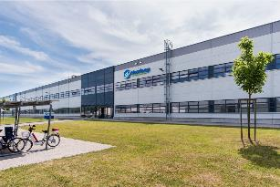 | Our Technical Center in Trenčín, Slovakia, is one of two major European research and development sites in Yanfeng’s global engineering network. With the Technical Center Yanfeng ensures that the company is close to its automotive customers and can offer its engineering excellence to even better meet their local needs.

02 Our departments in Trenčín – e.g. Product Development, Benchmarking

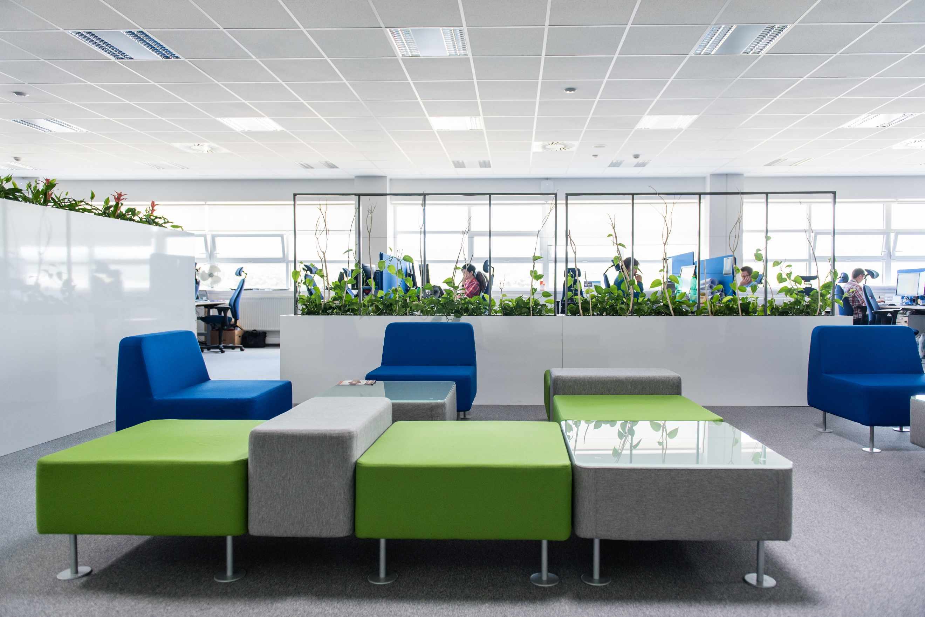  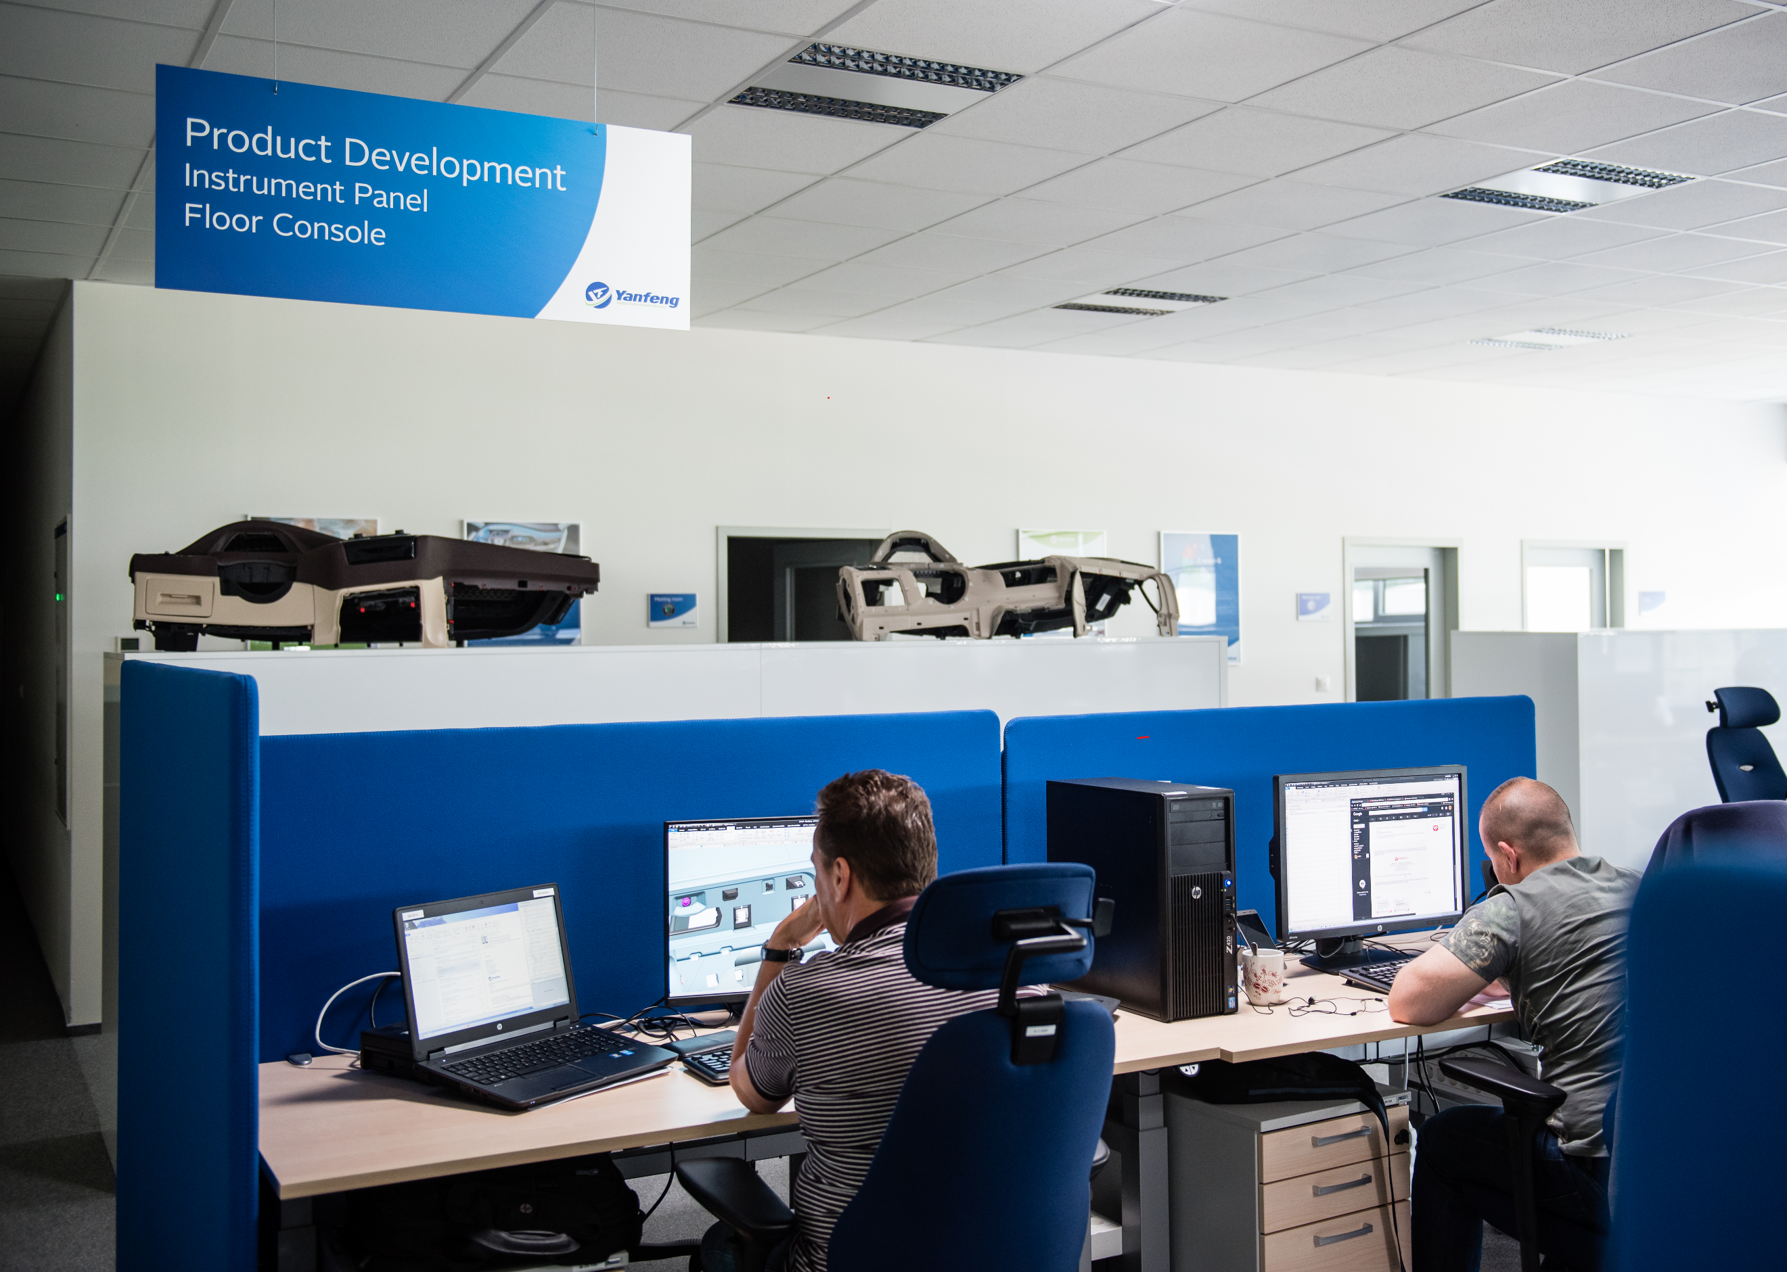  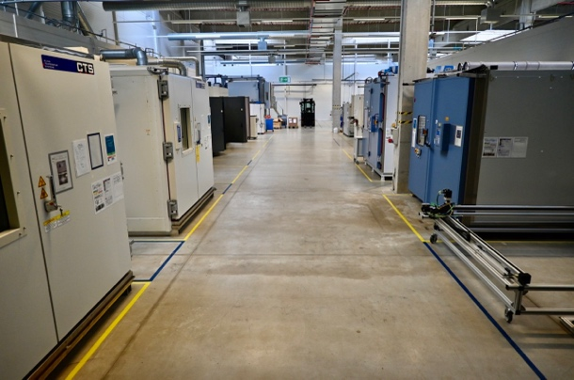 | Core departments at the Trenčín Technical Center are product development, benchmarking, environmental compliance, engineering systems and testing.  Modern office environment at our Technical Center in Trenčín.  The safety testing capabilities comprise several state-of-the-art durability, environmental, material and functional tests for airbags or steering wheels. The latest acquisitions comprise various systems to cover a 7-step environmental test loop required to confirm airbag module or steering wheel safety.  Over the past few years Yanfeng has been strengthening its testing capabilities for Central and Eastern Europe (CEE) in Trenčín. Since 2017 the company has invested continuously in additional testing equipment in line with its One Yanfeng strategy. First for its interior product portfolio and just recently also for its passive safety portfolio.

Our Testing Capabilities in Trenčín

Testing for Yanfeng’s Safety Product Portfolio

03 Environmental test loop for Airbag modules - Step #1 – Drop Tester

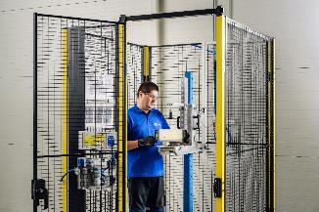  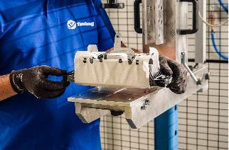 | In the environmental test loop for safety components, the drop test is the first step in the process. An airbag module or steering wheel is dropped approximately 800 to 1500mm to a solid steel surface via pin plug-in connection. This test has the purpose of observing possible damages to the products.

04 Environmental test loop - Step #2 – Mechanical shock tester
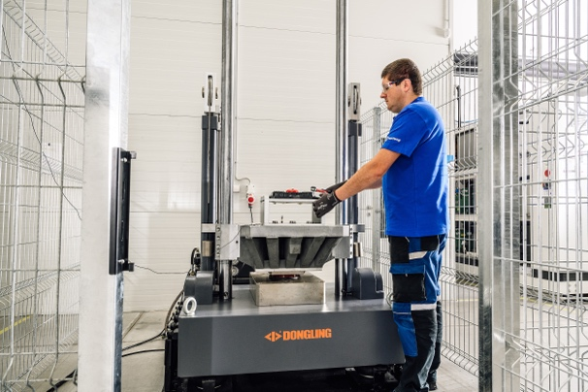  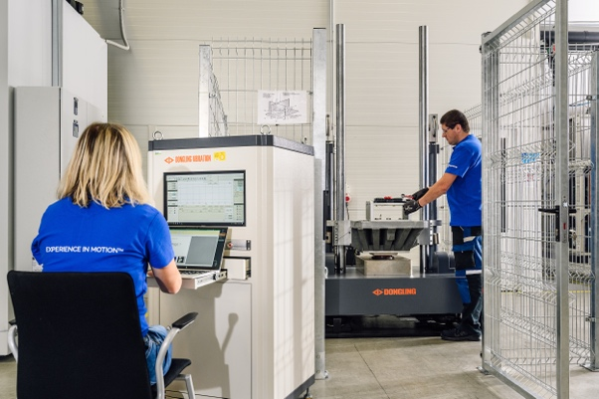 | The mechanical shock test has the purpose of testing the durability of automotive components. Depending on the tested part and its test requirements, the component is exposed to a sudden and forceful pull with different weights examining if it withstands the impact.  The female engineer is setting up the test according to the customer specification.

05 Environmental test loop - Step #3 – Dust tester

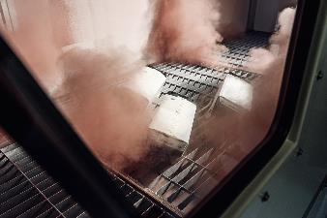 | The dust test is performed with a special dust from the Arizona desert over a period of 5 hours and serves to ensure that the functionality of the airbag modules proves to remain intact.

06 Environmental test for Airbag Modules - Step #4 and Interior – Vibration Test Shaker system

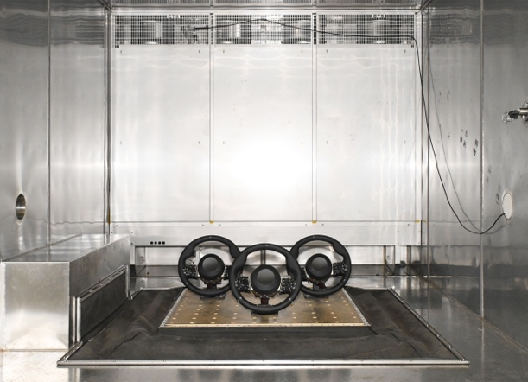  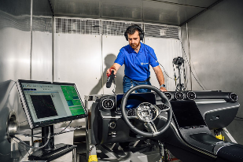  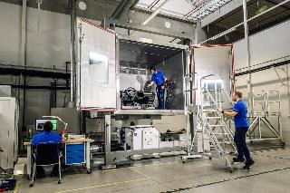 | With the three-axis vibration shaker, durability and noise tests are conducted on assembled components like a steering wheel or instrument panel. For buzz, squeak and rattle (BSR) tests we ensure that unwanted noises won’t be heard inside the vehicle later.  During the test, the engineer listens and evaluates, where there are unexpected noises e.g., frequencies of signals of the road but also additional customer specific tests.  Vibration Shaker with Steering Wheels: the parts are mounted on the fixtures and by that prepared for the noise test which is performed by shaking.

07 Environmental test loop - Step #5 – Temperature shock tester
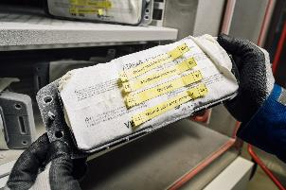  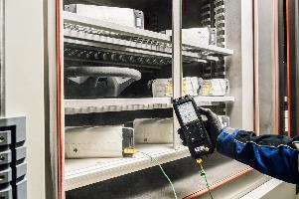 | The safety parts are tested by shocking them with high temperatures at first and afterwards low temperatures in a quick time frame. This is to reduce the risk of product failure due to temperature changes.

08 Environmental test loop - Step #6 – Salt Spray Chamber

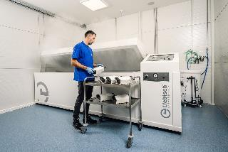  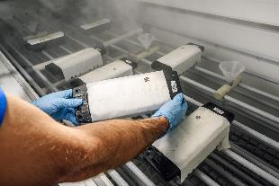 | The Salt Spray Chamber is a sort of a corrosion test, where salt steam is sprayed on the airbag modules. In the test, weight loss is evaluated with reference test plates to establish the corrosivity of the chamber. Test objects can be evaluated not just visually for visible corrosion but also for instance in regard to DIN EN ISO 4628-8 assessing the degree of blistering, rusting, cracking, flaking, delamination and corrosion around a scribe or other artificial defect.  The salt spray test simulates the corrosive loads on vehicles caused by the use of salt on winter roads as well as vehicle operation in coastal areas, on islands and the like (aerosol). The changing temperature relations aggravate this in particular. At low temperatures (dry air) the salt is deposited, at rising temperatures (humidified air) the dissolved salt begins to penetrate into the finest capillary openings, thus stimulating a chemical failure mechanism.
09 Environmental test loop of Airbag Modules End Step – Inflator Deployment

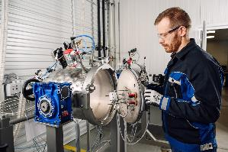  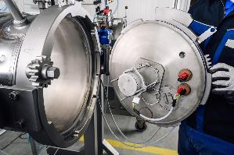 | During the tank deployment test a specific part of the airbag, the inflator, is deployed. Depending on what type of airbag is tested (passenger, driver, side, or curtain) three different tanks are used. At the end of the airbag module testing, the inflator is dismounted, and experts analyze whether the pressure of the deployment is according to the specification of the customer.

10 Airbag Deployment Testing for Interiors

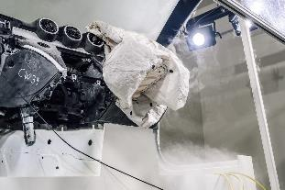  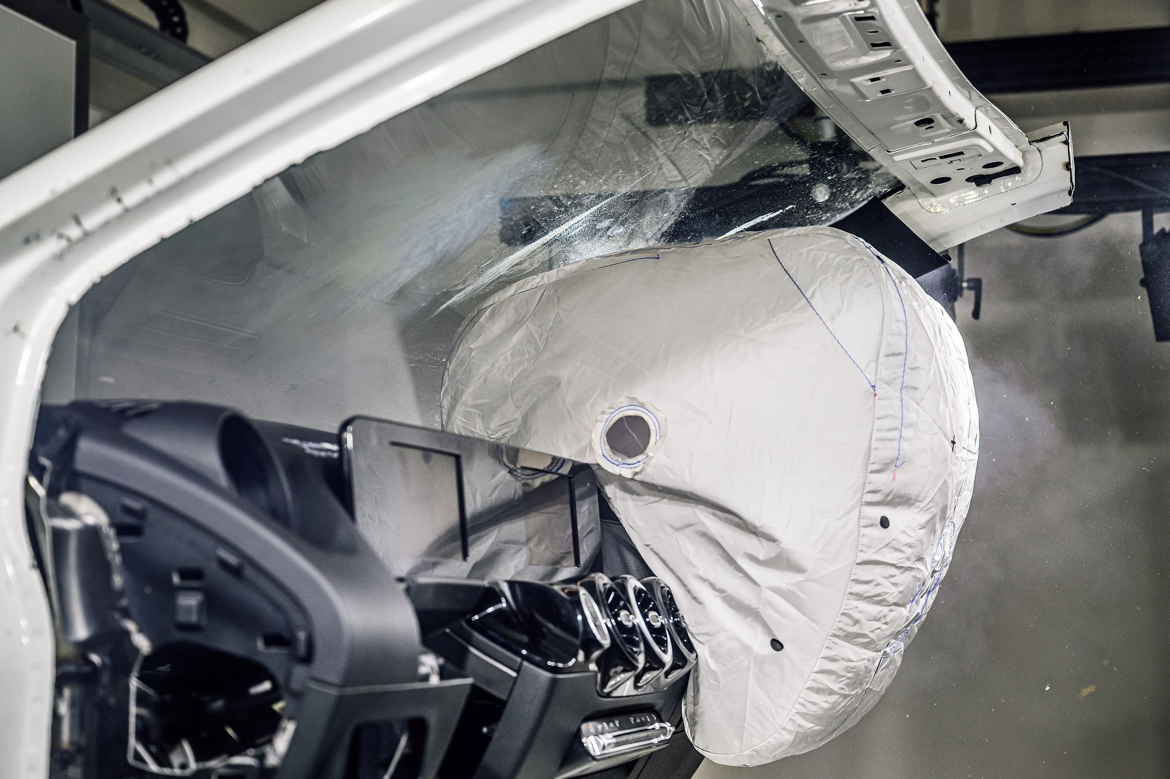  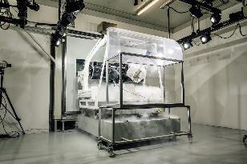  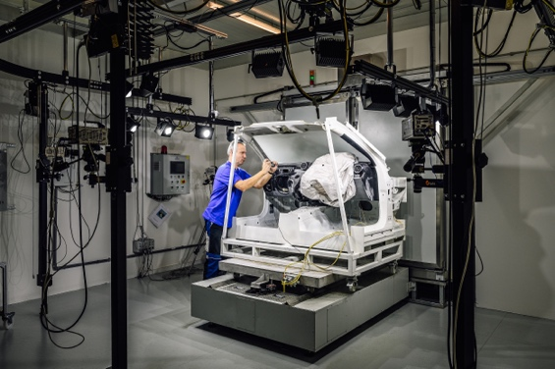 | We use high-speed cameras in our airbag test center to take up to 5000 frames per second during deployment of the airbag.  As a safety critical part, Airbags underly strict regulations as to how they need to be tested.  Three aspects are tested during the airbag deployment: the opening of the instrument panel airbag area, the maximum deployment (expansion) of the airbag and the moment when the airbag deflates.  These airbag deployments are performed in low, ambient and high temperatures. Conditioned instrument panel has to be moved out from the climate chamber and to be deployed within 8 to  10 seconds.  Expert analyzes the airbag shot to see whether the airbag system opens according to required specifications. In case of any flying particles out of tolerance and unexpected behavior of the system it needs to be redesigned.

11 Overview of the current airbag options in the vehicle interior

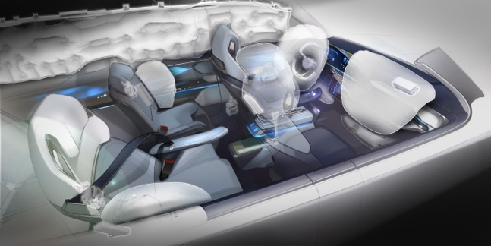  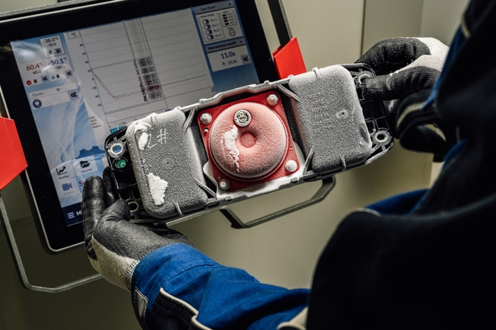 | Yanfeng’s safety product portfolio includes airbags, seat belts, restraint systems, and steering wheels. The airbags are integrated into the instrument panel, steering wheel, headliner or door panels for passenger safety. Side curtain airbags usually cover the entire length of the vehicle from the front to the rear row of seats.  Airbags must work perfectly all over the world – be it in Siberia or in the desert. An airbag module is exposed to all potential environmental impacts that might affect the product such as physical force, frost, sun, salt or dust.

12 Mechanical durability testing - Robot Test System F.R.I.T.S

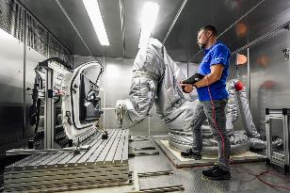  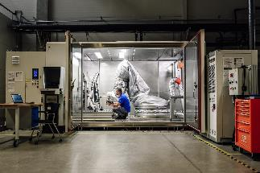 | Robot, which, in endless cycles, opens and closes the grab handles, presses the buttons etc. of a product to test its stiffness, rigidity and durability. Due to the numerous atmospheric differences such as humidity and different temperatures, the robot is equipped in a special dress.

13 Mechanical durability testing - Pendulum HIT 25P
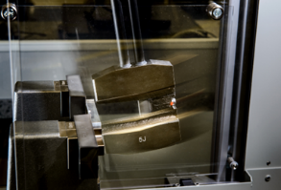  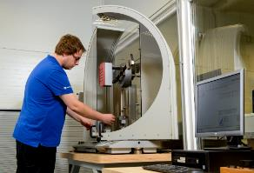 | The HIT pendulum impact tester covers the entire range up to 25 Joule of impact strength measurement for plastics (Charpy, Izod and Dynstat).
14 Scratch Hardness Tester
 | The motor-driven scratch hardness tester is a universal testing instrument designed for carrying out a wide range of tests on varnished and plastic surfaces to determine their resistance to scratches and cuts.

Example Testing

15 Solar Simulation System RS Climatic test chamber
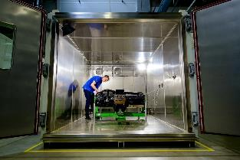  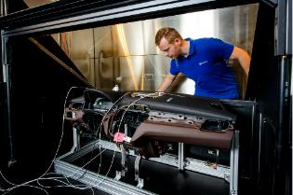 | The Test technician is attaching the temperature sensors to a tested part (Instrument Panel) according to exact given sensor positions specified by a DIN Norm inside a climate chamber. Long-term climate variation test and sun simulation test can be performed in this sunload simulation chamber.

16 3D Surface Scanning System / 3D surface inspection
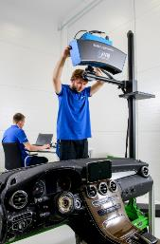  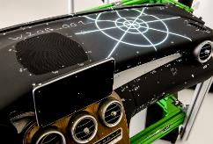 | The 3D scanner / 3D surface inspection generates the object's surface before and after the stressful heat ageing and climate change tests. These differences can be difficult to see to untrained human eye but are easily represented by software with deformation map in color.  The white marked area on the IP is the airbag chute.

Emissions testing

17 Fogging Tester Horizon AC-FTS

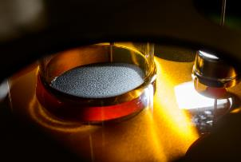  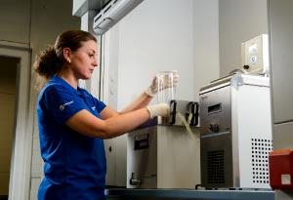 | The Horizon Fog Testing System is used for fogging emission tests of different plastic materials.

18 Odor Test Station
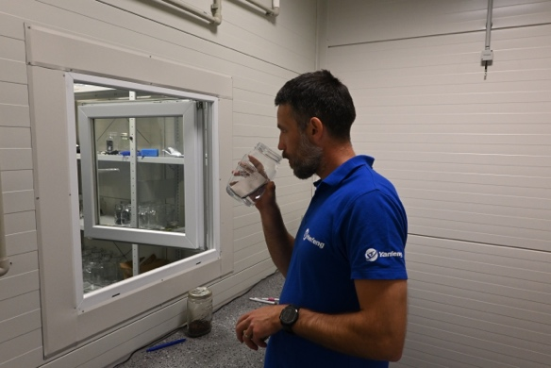  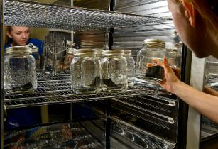 | Volatile organic compounds released from plastic are sometimes a source of unpleasant odor. Therefore, plastic materials undergo sophisticated olfactory tests.

